**Valleys:**

Kumrat Valley

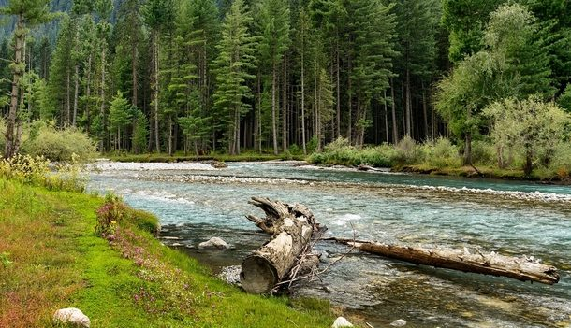

**Kumrat** is a valley in the Upper Dir District of Khyber Pakhtunkhwa the Province of Pakistan. It is one of the scenic valleys of Khyber Pakhtunkhwa and a picturesque spot for travelers. Every summer season thousands of tourists from different areas of the country visit to Kumrat valley and enjoy the greenery and cool weather.Kumrat is covered with green pastures, snow clad mountains, the river Panjkora, foggy mounds and forests are attractions of the region, which serve as habitats for variety of flora and fauna.It is located in the Upper Dir Kohistan region at the back side of which Swat Kohistan area of Gabral is located.

Hunza Valley

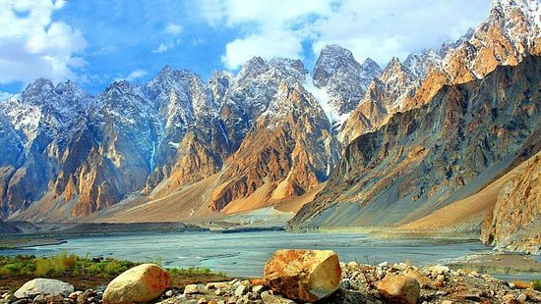

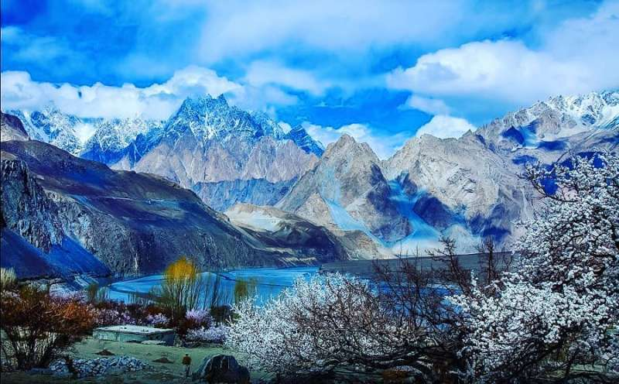

**Hunza** is a mountainous valley in the Gilgit-Baltistan region of Pakistan. Hunza is situated in the extreme northern part of Pakistan, bordering with the Wakhan Corridor of Afghanistan and the Xinjiang region of China. Hunza was formerly a princely state bordering Xinjiang (autonomous region of China) to the northeast and Pamir to the northwest, which survived until 1974, when it was finally dissolved by Zulfikar Ali Bhutto. The state bordered the Gilgit Agency to the south and the former princely state of Nagar to the east. The state capital was the town of Baltit (also known as Karimabad); another old settlement is Ganish Village which means "ancient gold" village.

Neelum Valley

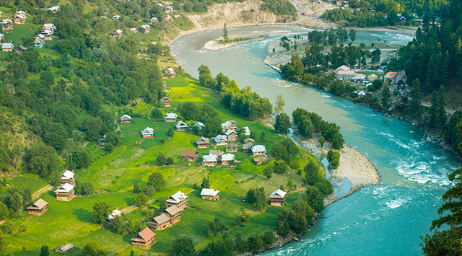

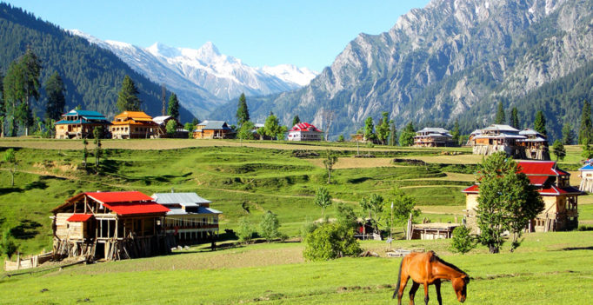

**Neelum District** (also spelt as **Neelam**; is the northernmost district of Azad Kashmir, Pakistan. Taking up the larger part of the **Neelam Valley**, the district has a population of 191,000 (as of 2017). It was badly affected by the 2005 Kashmir earthquake.

Leepa Valley

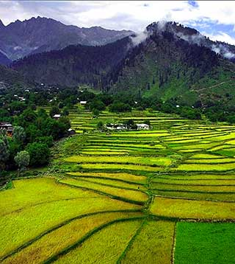

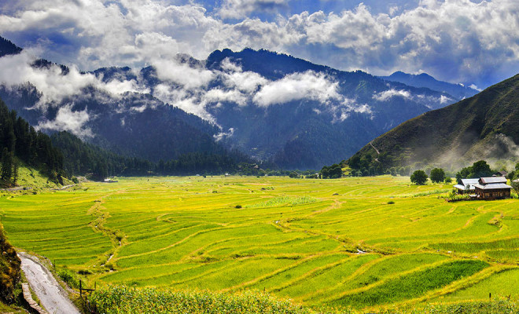

**Leepa Valley** is located in Azad Kashmir, 105 kilometres (65mi) from Muzaffarabad. The valley is divided into the Reshian, Dao Khan, Leepa, and Chananian sections. Leepa Valley was formerly part of Karnah tehsil of Kupwara district in Jammu and Kashmir, India. The valley is now part of Jhelum Valley District in Azad Kashmir, Pakistan. It has been an area of strife among the two neighboring countries.

Kaghan Valley

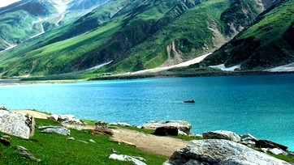

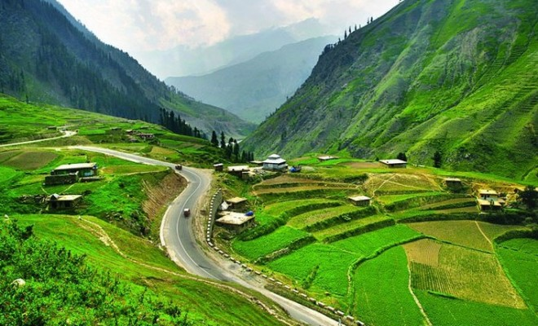

**Kaghan Valley** is an alpine-climate valley in Mansehra District of the Khyber Pakhtunkhwa Province of Pakistan. The tourists from across the country come to visit this place. The valley extends 155 kilometres (96mi), rising from an elevation of 2,134 feet (650 m) to its highest point, the Babusar Pass, at 13,690 feet (4,170 m). Landslides caused by the devastating 2005 Kashmir earthquake closed the Kaghan Valley road and cut off the valley from the outside. The road has been rebuilt.

Urak Valley

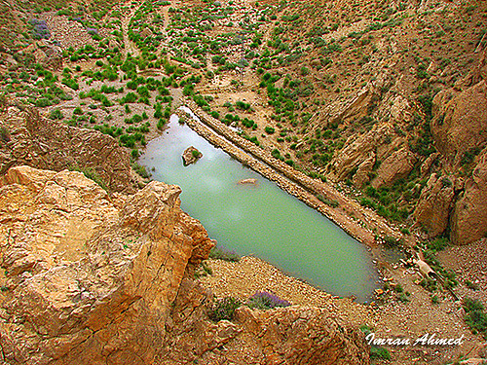

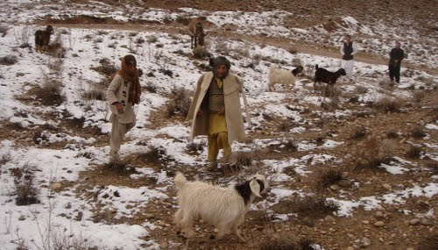

**Urak Valley** is a valley surrounded by mountains in the Quetta District of Balochistan Province, in western Pakistan. Urak Valley is located near Hana Lake, and 21 kilometres (13mi) from Quetta city. A small waterfall at its end marks entrance to the adjacent Wali Tangi Dam. Urak Valley has a population of 10,000, and is nearly 100% Kakar. Agriculture in the valley includes growing apple trees of good quality and a few other fruits.